Ifeoma U. Anyaeji

Ezuhu ezu (In[complete]) 2017 – Date (till whenever)
Description of Project

In my Plasto-artistic practice I work primarily with the superfluous medium of discarded non-biodegradable plastic bags and bottles and the receding techniques of a Nigerian traditional hair architectural practice called ikpa isi owu in Igbo which means “plaiting the hair with thread” (also known as hair threading or African hair threading). I revitalize their usefulness in society by transforming their functionality, extending their value and potentialities back into our environment. However, repurposed objects are like second-class citizens (aliens) and do not quite enjoy the same privileges as their new factory distributed counterparts. Since we have been conditioned to see things look and function in a certain way, there is always that hesitation towards how aesthetically finished and functionally competent repurposed objects are. This why I am interested in redefining aesthetic reuse practices, cum today’s contemporary contemplations, using nonconventional techniques and practices, or what I refer to as materials of opportunity and creative extension, to, recreate a neo-traditional interpretation that references historical ideologies on the concepts of waste management, material culture and visual aesthetics in pre and post-colonial times of my place of origin – Nigeria – and how it affects what composes my immediate environment.
During my moments of remodeling these mundane ubiquitous plastic waste materials I have observed that my choosing to exonerate the antagonistic portrayal of plastic bags as the enemy of our environment, when instead it is a fundamental part of our existence and sustainable potent resource, is no different from the recent social behaviours to ethnic differences and territorial preoccupation. That to be complete and ‘whole’ does not always translate to physical homogeneity. Instead, our evolving cultural textures and displacements (deliberate or not) should be the symmetry that enable us to truly excel and be consistent (after all no one cooks soup with just the pot serving as the only tool and the entire ingredient as well). In the context of seeking social and geographical balance and trying to ascertain my belonginess in any space, irrespective of how long one has existed there, I always (allegorically) question what establishes an artwork as finished, completed, and accepted in its space of display. Is it the genuine feeling of fulfilling the objective arrived at the moment when the artist drops her tools and signs off on the work? Or is it the restriction of a superficial timing, usually caused by an external deadline? I always believed that each of my works exhibited are never really completed because of the race to catchup or meet with the expectation of an art scene that requires you to keep going, going, and going with less time to fully observe, make, observe again and digest then enjoy what has been made before choosing to share it with anyone else. Therefore, I made a conscious decision to always keep extending any of my works still in my possession. Afterall, the premise of my practice is to create balance by prolonging value and to harness as much possibilities as can be derived from my mediums and methods of crafting. So far, I have succeeded in doing this but none of my works have I kept in a perpetual mode of extension like I have done with the artwork Ezuhu ezu (In[complete]).
Ezuhu ezu (In[complete]) is a crafting journey that began in 2017 when I was asked to create my interpretation to an English translated Utopian Yiddish-language novel, titled "In Der Tsukumft-Shtot "Edeniye" ("In the Future City "Edeniye”) written in 1918, shortly after the Russian Revolution, by writer and publisher Kolmon Singman in the Ukrainian city of Kharkiv. The author describes a futuristic city called "Edeniye," situated someplace in Ukraine in the 21st century. Edeniye is a high-tech Utopia, characterized with futuristic architecture and technology plus a multiple ethnic community, including Ukrainians, Jews, Pols, and so on. In this utopia, each ethnic community co-existed peacefully while enjoying cultural and linguistic autonomy and appreciating each other’s civilization. Within the remarkable features of this science fiction is a melancholic story of lost endearment between two persons, an unfinished relationship, and a search for hope.
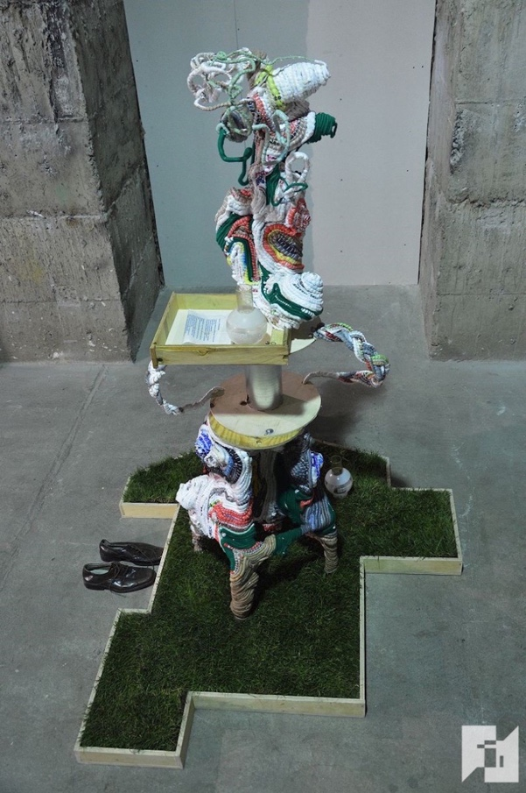
Ezuhu ezu (In[complete]) became my pilot project to challenge the norms of commercialized art as finished products ready to be consumed, in a “presentable” form, in a white cube or orthodox exhibition space. The objective was to terminate this finitude by continuously creating this craft-artwork. Its expansion will only be done at the point and place of exhibition where I semi-colonize these spaces as temporary studios for threading all discourses and dialogues that ensue with each journey of the work’s installation. In otherwards – the magnitude of the work – the expansion and or compression of the whole installation is influenced by the temporary studio spaces – aka exhibition rooms. But what is most important about this transiting piece is how the viewer – you – assimilate what is being shared with you (using your entire senses and immersing bodies and listening to the identical language spoken by the processes and elements of the work – without the distractions of social objects (social mediums – including phones and photographing).
First installation at Yermilov Center, Kharkiv, 2017

For the title of this project, the first part is written in my dialect of the Igbo language, and it means ‘incomplete’, ‘insufficient’ or ‘not enough’. My translation of this Igbo phrase, in the second part of the title “(In[complete]), is a play on meaning and expresses two ideas – to be 'in the process of completing something', within which there is always a recognized ‘completeness', depending on how we chose to perceive that completion. The installation Ezuhu ezu is incomplete, and always left unfinished to imply that something is missing. Yet, at the very moment any viewer (other than myself) sees the work in an exhibited state it is assumed to have been completed. By aesthetic standards the sculpture portrays a wholesomeness, but the entire installation subtly shares a continuous state of uncertainty and a longing to find relevance within each space it is exposed or revealed at. This wholesomeness is akin to our collective validation in times of happiness, joy, nostalgia, disbelief, pain or surprise while the uncertainty is our need to be positioned or integrated into an external community, which could bring cultural renewal, reappropriation, and extensiveness or acceptance.
Second installation at BALTIC Center, Gateshead, 2019
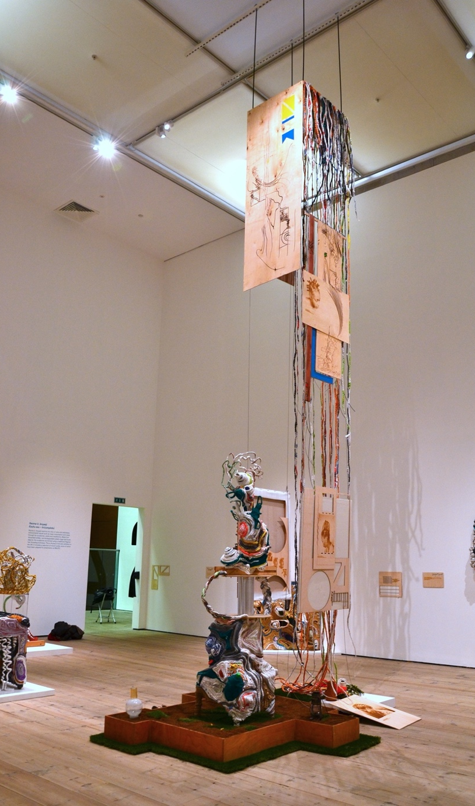
Although the work has an open theme, Ezuhu ezu (In[complete]) takes on the idealist setup of the futuristic Edeniye city to examine the connectivity and continuity between place, time, culture and expectations in human-environmental relationships and what it means to be selectively useful as part of a future yet alienated as an incompatible other. With a perceptible characteristic of being handcrafted over and over again, the work inherits the materiality of our fragile yet susceptible ubiquitous eco-system whose stamina depends on the substructure of a deconstructed or decomposed multiethnic space.

After, its first display of this work at the Yermilov Center, Kharkiv, in 2017 there came two other opportunities to continue this journey towards completion. One of them was in September 2018, when Emma Dean the curator of the BALTIC Center for Contemporary Arts in Gateshead, United Kingdom, invited me to exhibit a selection of my artworks in one of their exhibition spaces at the center. The solo exhibition was in two parts – first there the central project Ezuhu ezu (In[complete]) - also the title of that exhibition – surrounded by other completed sculptures. Then there was the takeover of the gallery space as my personal workspace for extending the central pieces using the used non-biodegradable plastic bags and bottles collected from and around the BALTIC community, prior to my arrival.
Second installation at BALTIC, Gateshead, 2019

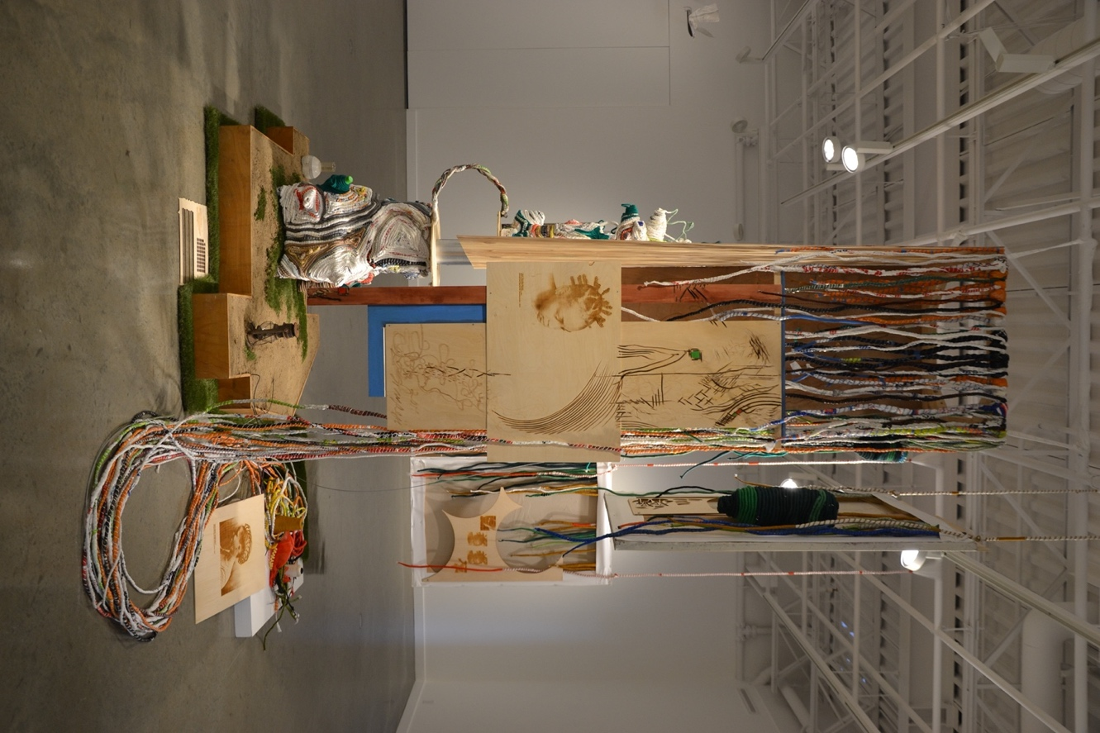
The third re-editing and expansion of this sculptural installation piece - Ezuhu Ezu [In(complete)]’ occurred in 2020 at the Centre d’exposition L’Imagier, Gatineau. Quebec where I was invited by Nuria Carton de Grammon to participated in a group exhibition titled “The Work itself”. This exhibition focused on the concept of work as more than an economic activity and a need to re-establish the value of the handmade but also as a socio-cultural and geo-political dimension for artists to tackle sensitive questions like productivity and the lessening relationships between human activities and their territorial bases, ecology and labour (especially at these present times of the global pandemic) from a standpoint of cultural, geographical and political uprootedness, including the notions of identity and belonging that arise from these questions. In Nuria Carton de Grammont words: "Beyond productivity and the capital it constitutes, ‘work’ highlights space as an affirmation of practices, know-how and traditions” while "[labour] represents a will to claim identity in its relationship to the construction of the territory in its geographic, as well as in its sensorial dimensions". By ensuring that the continued crafting of this sculptural piece during the exhibition remains an on-going labour and an uncompleted work (probably complete for a viewer), the whole process of creating this work is to challenge any typical layouts for a concluded existence and the expectation or reference to artworks or our existence, by formal spaces of display, geo-cultural borders, as definitive - ‘finished products’.
Third installation at Centre d’exposition L’Imagier, Gatineau 2020
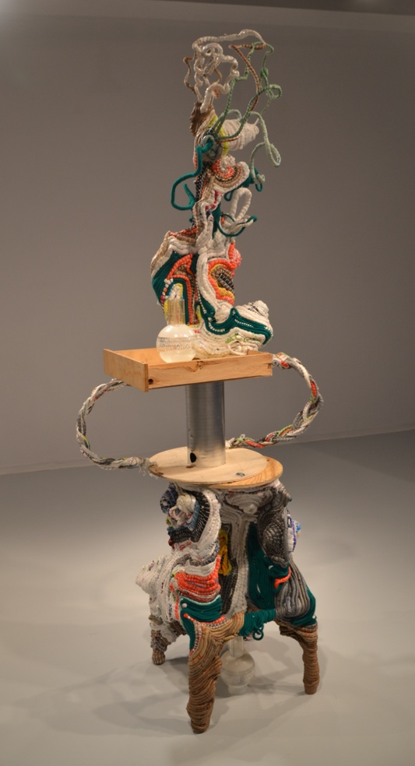
At the moment, Ezuhu ezu has been extended from a single standing structure to an animated installation with several components made from found and etched wood panels, crafted plasto-yarns*and bottles, earth, and found objects and written English and Igbo texts that have been translated into the official languages of the places the work has been installed. Also included are some excerpts of photographic documentations of a receding traditional Nigerian Hair practice (Threading)– conducted in two separate research travels to Nigeria in 2017 and 2018. The sculpture and etched photographs included in the installation were created during the course of 3 years as part of my studio practice and research creation work for my PhD studies. The 2019 installed setup involved a spontaneous public participatory reaction shared at the opening of the exhibition, which I see as non-performative because it was a point of vulnerability for me that I could only shrug off through that gestural fulfilment and its ensuing commentary. However, for this next installation at CIRCA, I may or may not offer such reaction. Since it will all depend on how my working at the space is impacted.

Like in the previous displays Ezuhu ezu (in[complete]) looks beyond our regulated relationship to any terrain we occupy, a relationship further modulated by the unending dynamics of contrived subsistence. And so, it is always interesting for me to see how the characteristics of this work changes again to adapt to the limited structure of the CIRCA space as well as the restrictions of the Covid-19 reign. Since this is one art piece whose completion, I still have control over when it ends – the one where I can continue to document, transmit, change, add or retract my thoughts and understanding of this opportunity to exist. I cannot say all that the work is supposed to mean, or do, nor will I know when it will be completed and if the title will change when it is done. But when I do finish this project, hopefully, it will all make more meaning than I can write down here.
Ezuhu ezu (In[complete]), Ifeoma U. Anyaeji © 2017
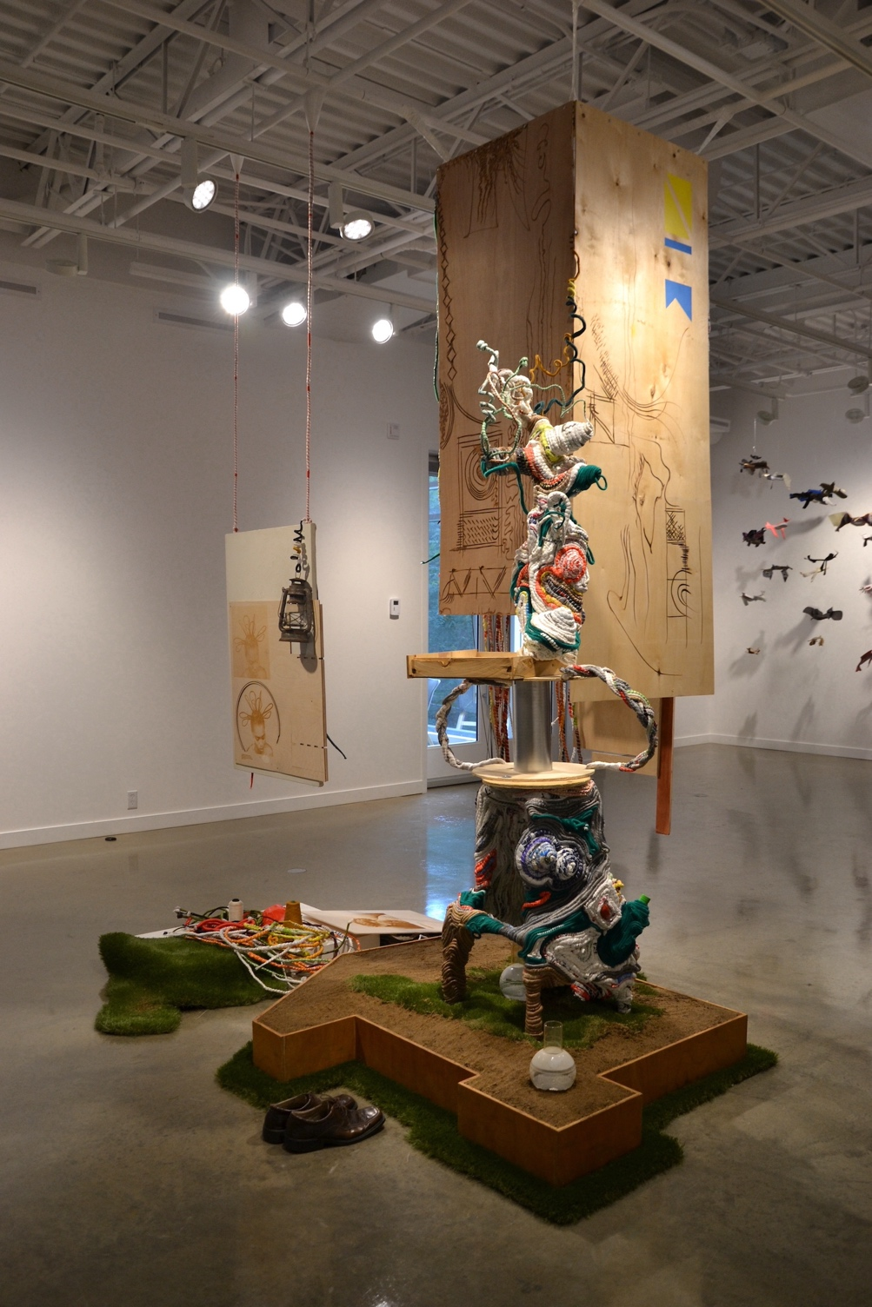

Credit and Copyright ©: Ifeoma U. Anyaeji 2019
Artist: Ifeoma U. Anyaeji (Nigerian)
Title: Ezuhu ezu (In[complete) Type: Sculpture installation (third) Year(s) of creation: 2017 - Extension Continues Materials: Repurposed discarded non-biodegradable plastic bags (Plasto-yarns), found objects, twine, metal, wood, faux/ real grass, earth composite and texts (Igbo, English, Ukrainian and French)
Current dimension: Varied
Style: Plasto-art (Neo-traditionalism)
Technique: Plasto-yarning
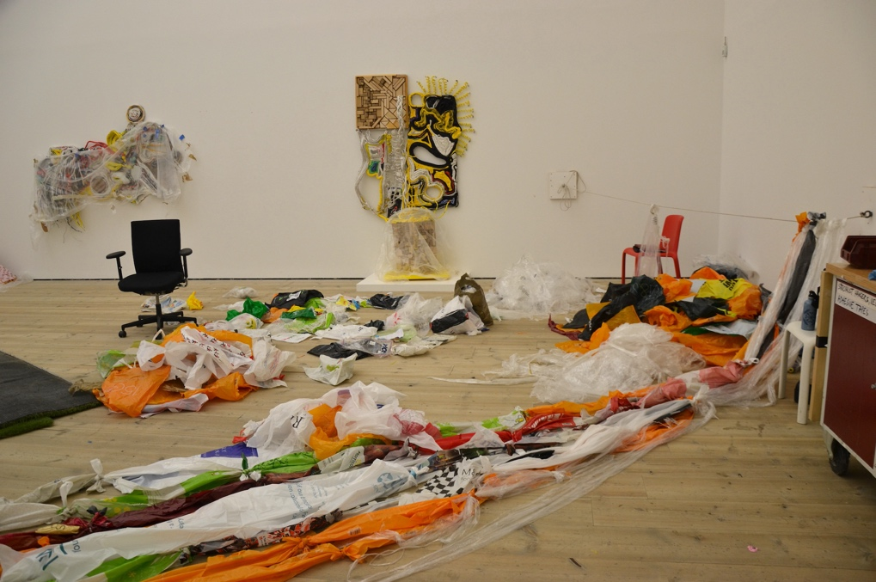
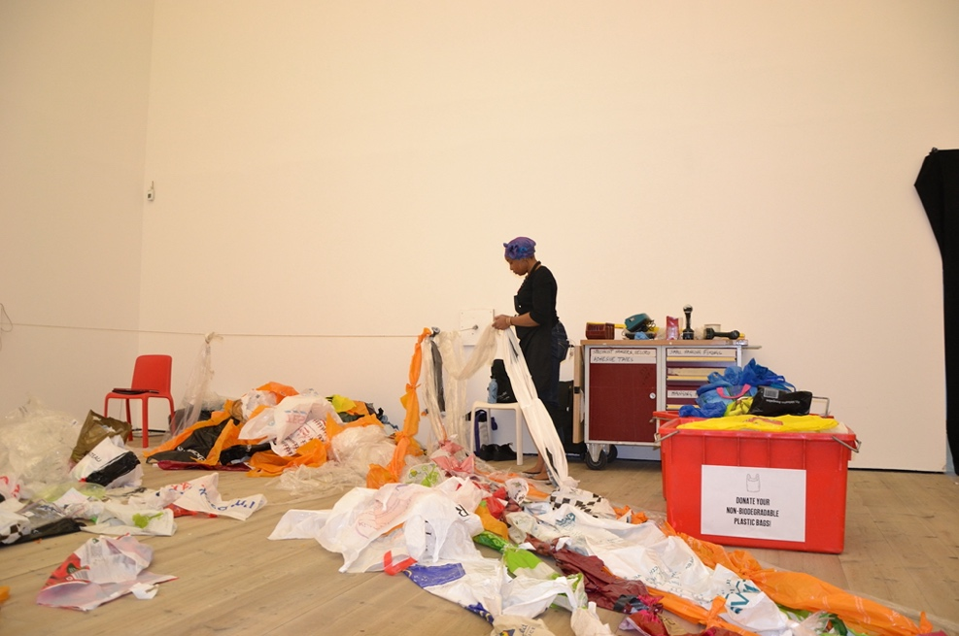
Colonizing the BALTIC Center exhibition space

(Double click image to play video – © BALTIC, Gateshead – 2019)
Part of the spontaneous public participatory reaction shared at the opening of the 2019 installation

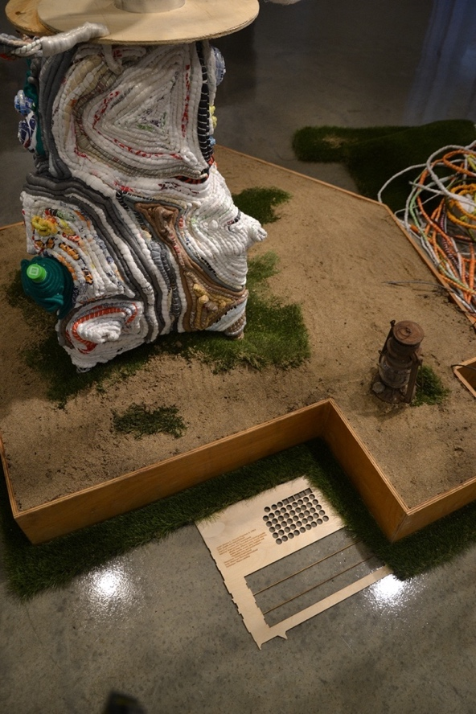

These are discarded non-biodegradable plastic bags that have been crafted into yarns using, a traditional Nigerian hair technique, which are then used to create my sculptures.

